Software Design Document

Supermarket Management System

Introduction
This project implements a console-based Super Market Management System in C++. The system provides administration features (manage items and employees) and a Point-Of-Sale (POS) for employees to process billing, manage inventory levels, and reorder stock. The program demonstrates file I/O, basic encryption for stored credentials, and simple user authentication.

Product Scope
The Supermarket Management System will:
- Maintain an inventory of items (name, type, quantity, price).
- Store administrator and employee accounts (simple XOR obfuscation used for storage).
- Allow Admin to login, add items, and add employees.
- Allow Employees to login, perform billing (select items and quantities), and handle payments.
- Automatically reorder items when stock falls below a reorder level.
- Persist data in text files (items.txt, admin.txt, employees.txt).

Requirements
Main components / classes:
- Utility: Helper functions (trim, xor22, to_int, clear_screen)
- Item: stores details such as item name, type, quantity, and price
- InventoryIO: load/save inventory and seed default items
- AccountIO: load/save account lists and seed default admin/employees
- AdminPanel: admin authentication and management functions
- POS: employee authentication, billing, inventory modifications, reorder logic
- main(): program menu and orchestration

Assumptions
- The program runs in a console window; no graphical interface is used.
- All inputs such as quantities and prices are positive integer values.
- The files admin.txt, employees.txt, and items.txt are located in the same folder as the program.
- If a file does not exist, the program will automatically create one with default data.
- The default login credentials for both admin and employee are username: afraaz and password: afraaz123.
- The program is intended for local use only (no internet connection is needed).

Design Overview

Pseudo Code

At start-up, the program will output a welcome message.

Ask the user to choose a role:
1 for Admin, 2 for Employee (POS), or 0 to Exit.

If the user chooses 0, output “Goodbye!” and end the program.

If the user chooses Admin:
Ask for username and password.
Verify credentials from admin.txt.
If incorrect, output “Invalid login” and ask again.
If correct, output “Hello Admin.”
Show the Admin Menu:
1 to add a new item
2 to add a new employee
3 to sign out

If the admin selects 1:
Ask for item name, type, quantity, and price.
Add the item to items.txt.
Output “Item added successfully.”

If the admin selects 2:
Ask for new username, password, and confirm password.
If username exists, output an error.
If passwords don’t match, output an error.
Otherwise, save the new employee to employees.txt.
Output “Employee added successfully.”

If the admin selects 3:
Return to the main menu.

If the user chooses Employee (POS):
Ask for username and password.
Verify credentials from employees.txt.
If invalid, output “Incorrect user or password” and ask again.
If valid, output “Logged in successfully.”
Load items from items.txt.
If file not found, create it with default items and load again.
Output all items with names, quantities, and prices.

Start billing loop:
Ask for item number (or invalid number to exit).
If valid, ask for quantity.
If enough stock:
Add (quantity × price) to total.
Reduce item quantity.
Output “Item added.”
Else output “Not enough stock.”
Repeat until invalid item number entered.

Output bill with items, quantities, and total.
Ask for amount paid.
If less than total, ask again.
If equal, output “Paid.”
If greater, output “Paid… change: (amount paid - total).”
Save updated inventory to items.txt.

Check for items with quantity ≤ 50.
If found, add +50 to their quantity.
Output “Ordering <item> from supplier.”
Save inventory again.

Ask “Next order? (1 for yes, 0 to sign out).”
If 1, repeat billing.
If 0, output “Signing out…” and return to main menu.

If admin.txt or employees.txt does not exist, create them with default credentials:
username = afraaz, password = afraaz123.

If items.txt does not exist, create it with default items:
Tylenol, Aspirin, Ibuprofen, Multivitamins, Lays-Salted, Doritos-Flamas.

End program.

Flow Charts
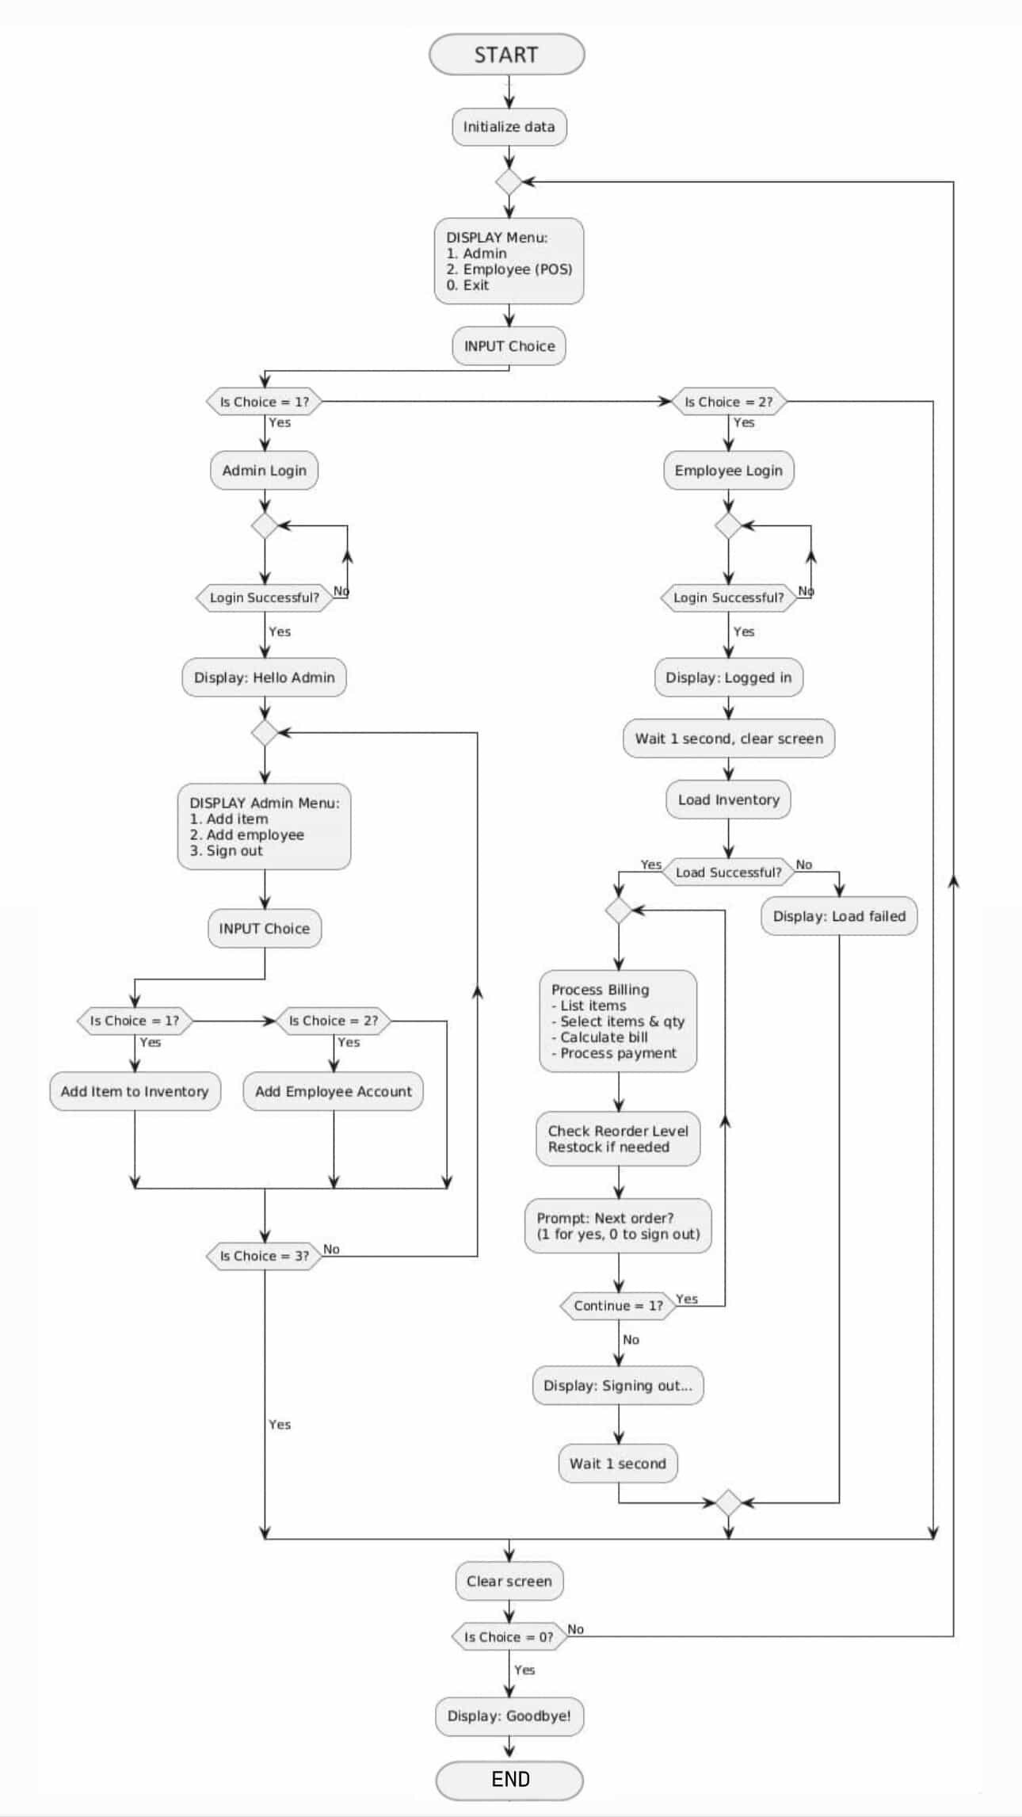

Class Diagram

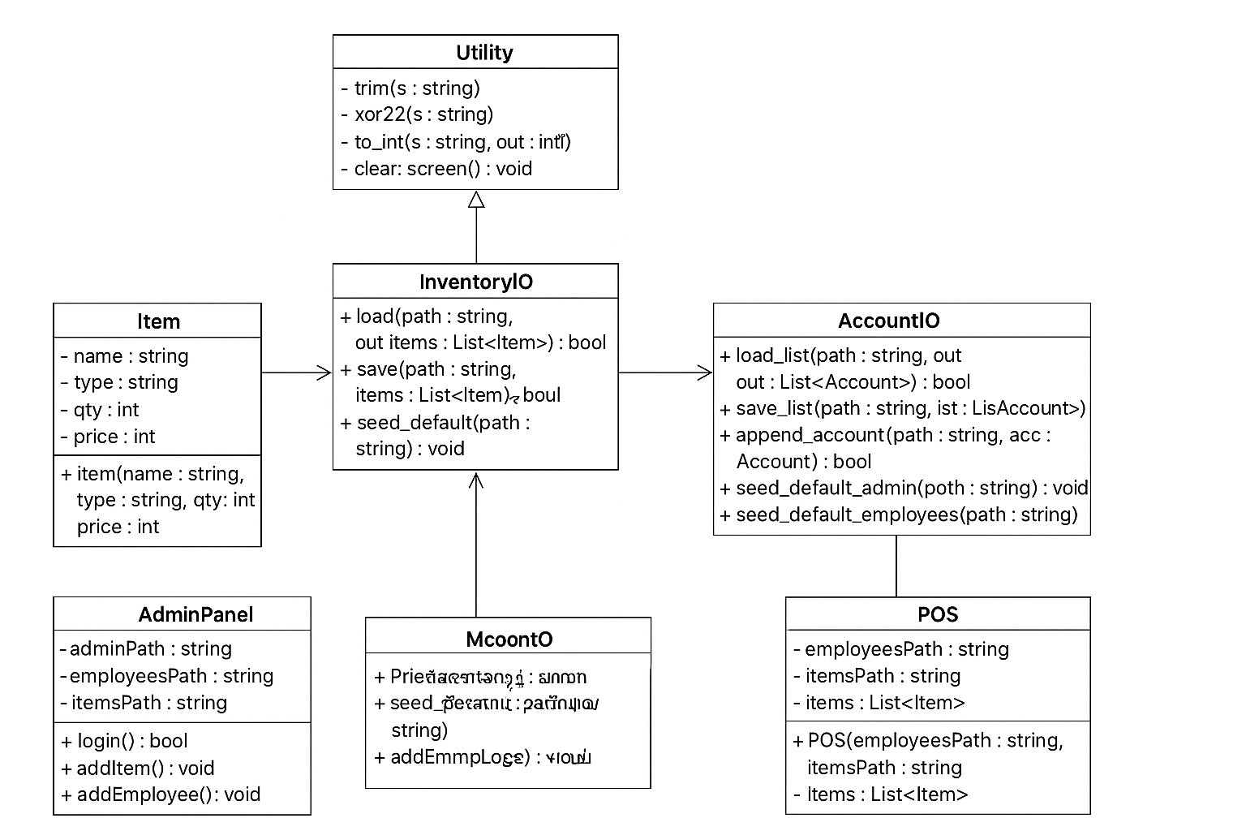

User Interface
Console-based menu-driven interface. The top-level menu lets the user choose Admin or Employee mode or Exit. Admin mode requires admin credentials; after login the admin can add items or employees. Employee mode requires employee credentials and allows billing and inventory updates.

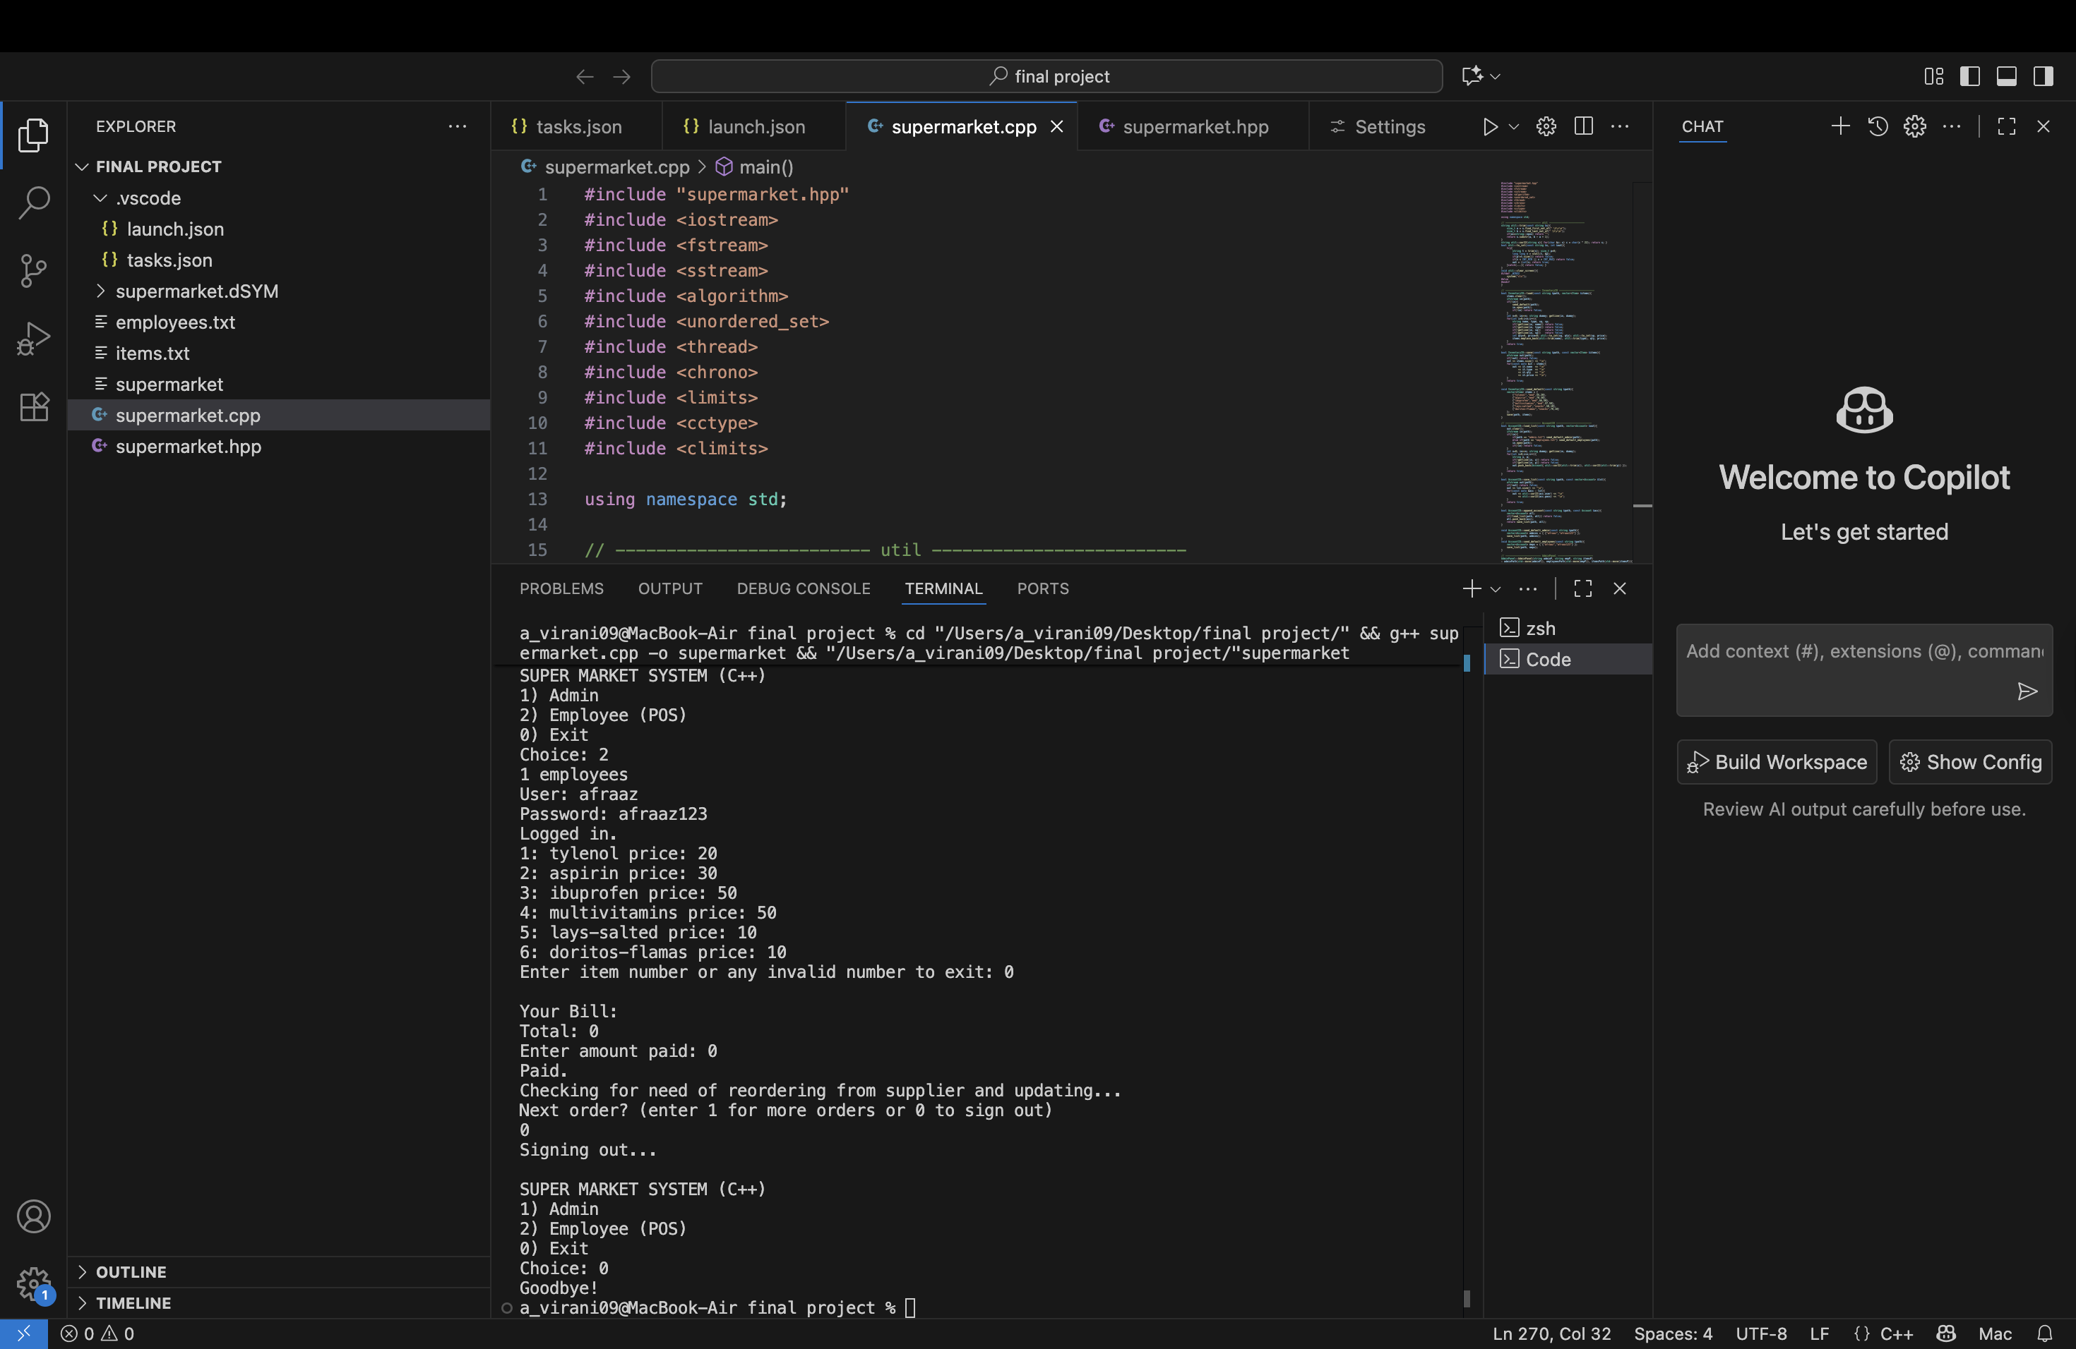

Testing
To make sure the program works correctly, the following test cases will be performed:
Test Case #1
Description: Run program with no data files present.
Expected Result: Program creates all missing files (admin.txt, employees.txt, items.txt) with default data.
Test Case #2
Description: Admin login with correct username and password.
Expected Result: Output “Hello Admin.” and open Admin menu.
Test Case #3
Description: Admin login with incorrect credentials.
Expected Result: Output “Invalid login” and prompt again.
Test Case #4
Description: Add new item from Admin menu.
Expected Result: Item is added to items.txt and output “Item added successfully.”
Test Case #5
Description: Add new employee from Admin menu.
Expected Result: Employee is added to employees.txt and output “Employee added successfully.”
Test Case #6
Description: Employee login with correct username and password.
Expected Result: Output “Logged in successfully.” and open billing menu.
Test Case #7
Description: Employee login with incorrect credentials.
Expected Result: Output “Incorrect user or password.” and prompt again.
Test Case #8
Description: Employee selects valid item and quantity.
Expected Result: Item added to bill, total updated, and stock reduced.
Test Case #9
Description: Employee enters quantity greater than available stock.
Expected Result: Output “Not enough stock.” and reject input.
Test Case #10
Description: Customer pays less than total bill amount.
Expected Result: Program prompts to re-enter payment amount.
Test Case #11
Description: Customer pays exact total amount.
Expected Result: Output “Paid.”
Test Case #12
Description: Customer pays more than total amount.
Expected Result: Output “Paid... change: (amount paid - total).”
Test Case #13
Description: Stock falls below 50 units after billing.
Expected Result: Program automatically adds +50 to quantity and outputs “Ordering <item> from supplier.”
Test Case #14
Description: Enter letters instead of numbers for quantity.
Expected Result: Output “Invalid input.” and prompt again.
Test Case #15
Description: Leave username or password field blank during login.
Expected Result: Output “Invalid login.” and ask again.
Test Case #16
Description: Manually delete one or more data files before running program.
Expected Result: Program recreates missing files with default data.
Test Case #17
Description: Exit program by selecting option 0.
Expected Result: Output “Goodbye!” and terminate program.

